Jared Raiola - 903293358

Homework 3

PART 1 - LAB

I am using the given trace for every question except question 3.

1. 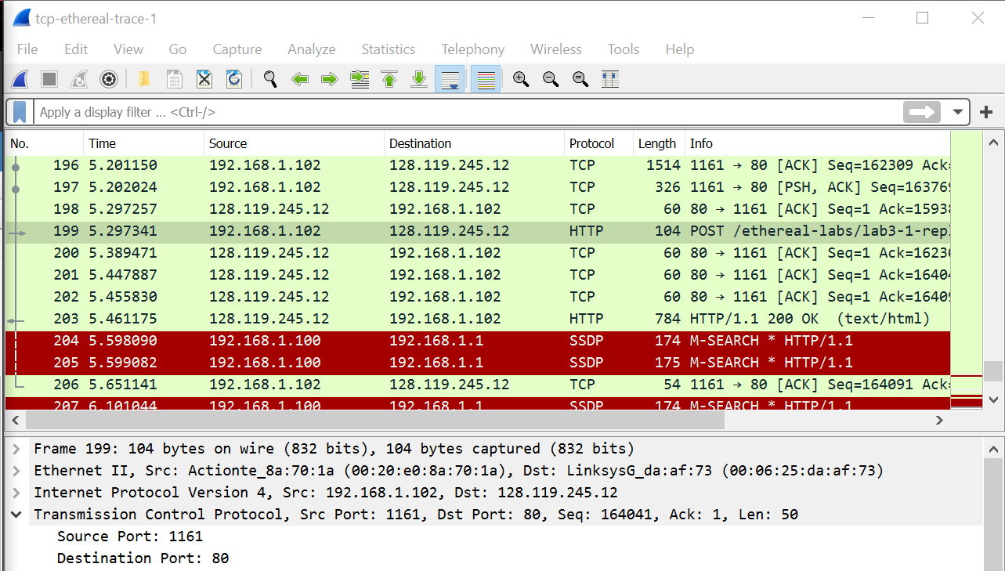
   1. Selecting HTTP at Frame 199 provides us with a client IP address of 192.168.1.102 and a TCP port number of 1161.
2. 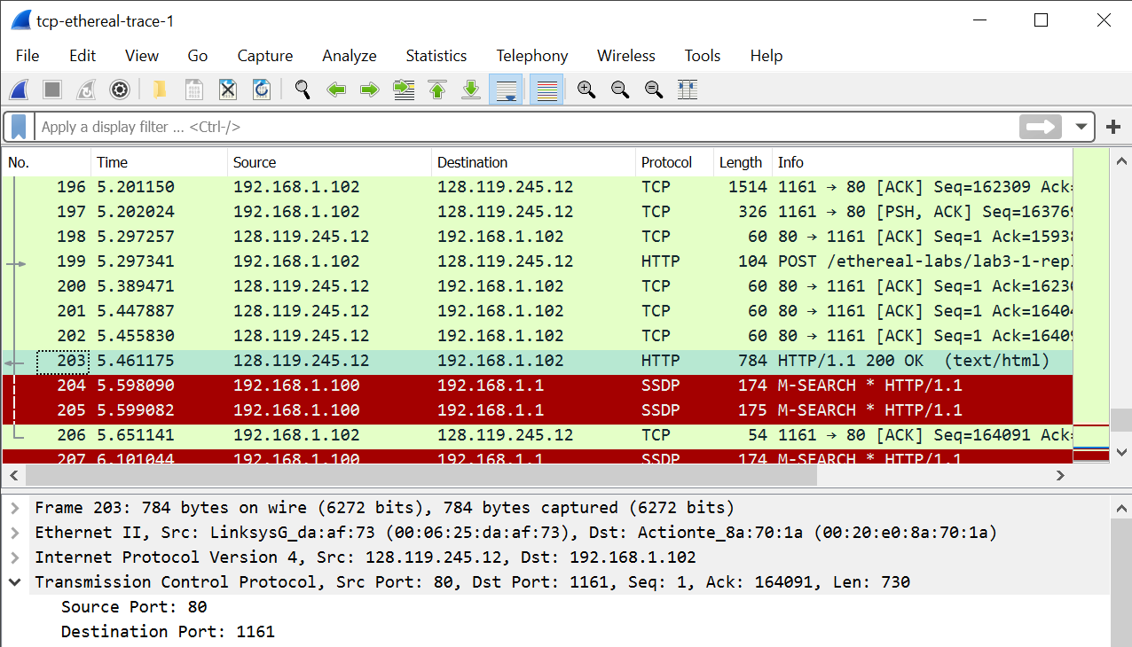
   1. The IP address of gaia.cs.umass.edu is 128.119.245.12 and the TCP port number is 80.
3. 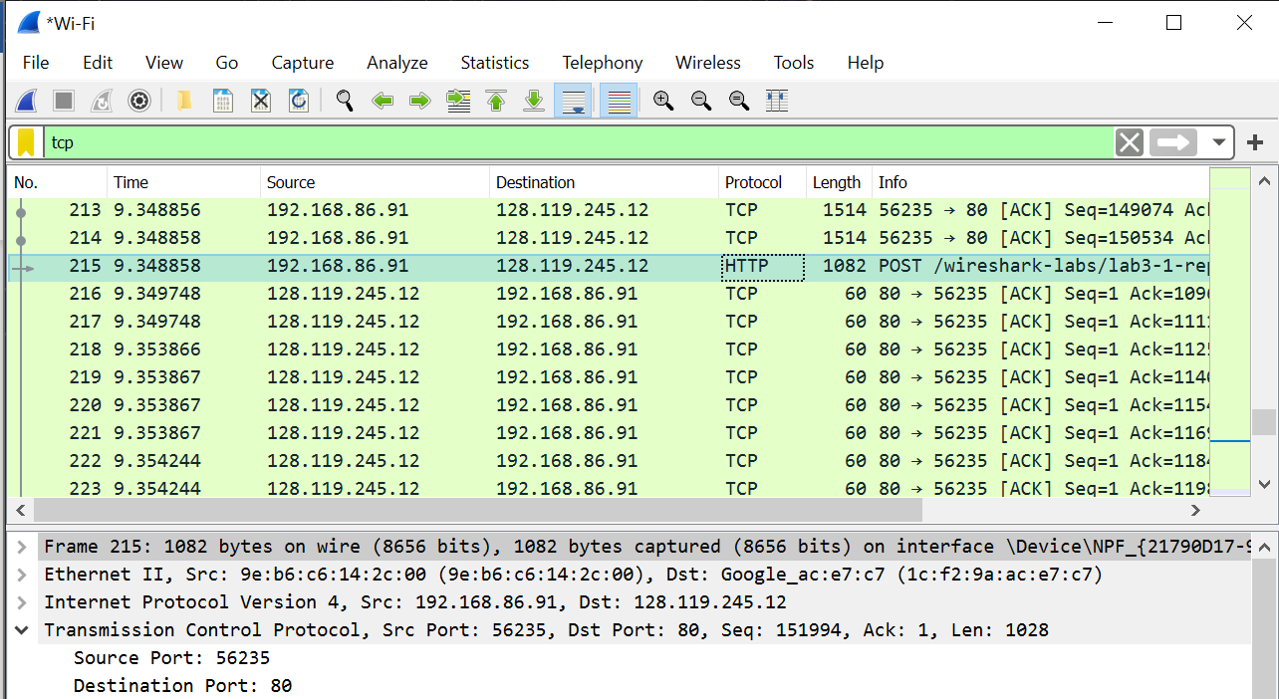
   1. The IP address of my computer is 192.168.86.91 and the TCP port number is 56235.
4. 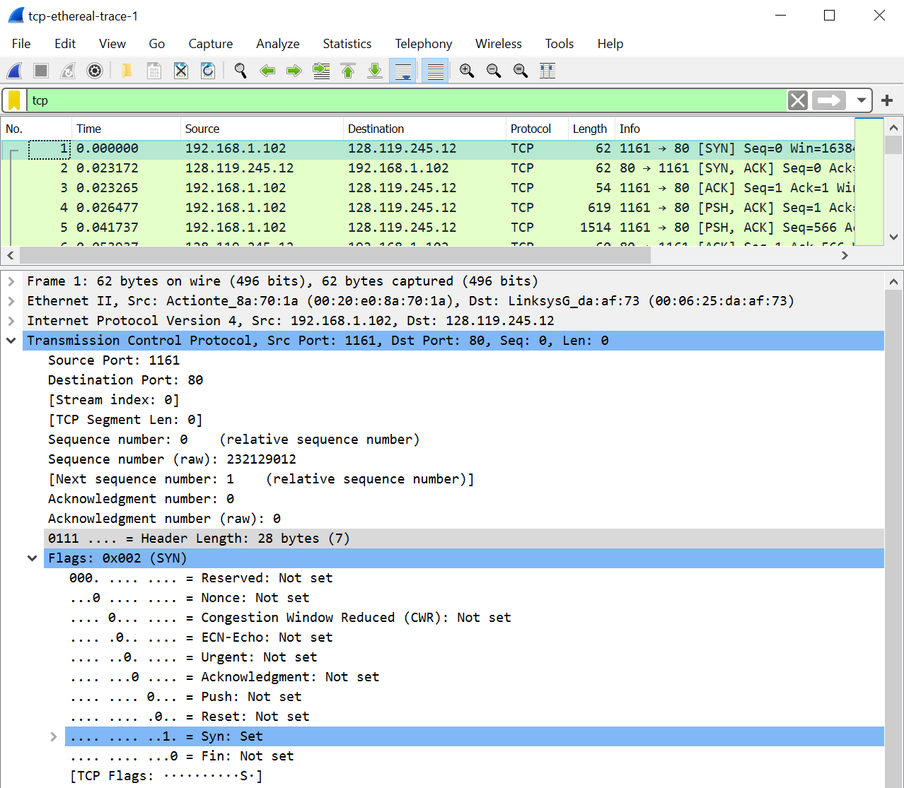
   1. The sequence number of the TCP SYN segment is 0. The SYN flag is set to 1, identifying it as a SYN segment.
5. 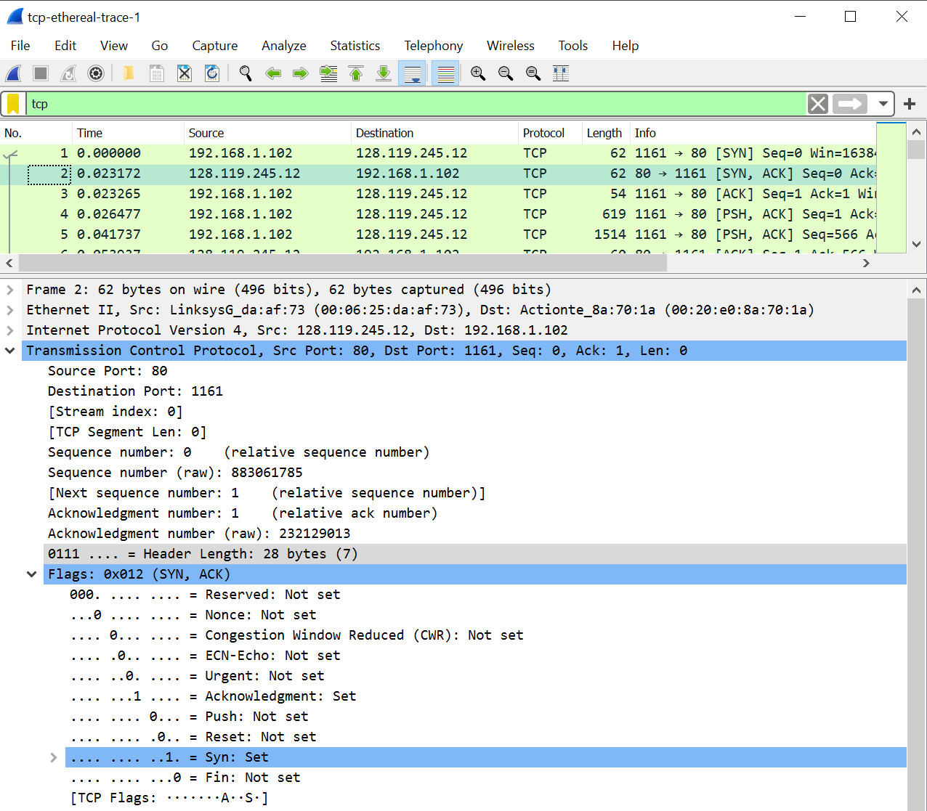
   1. The sequence number of the SNYACK segment is 0. The value of the Acknowledgement field is 1. This segment is identified as a SYNACK by the Acknowledgement and Syn flags both being set to 1.
6. 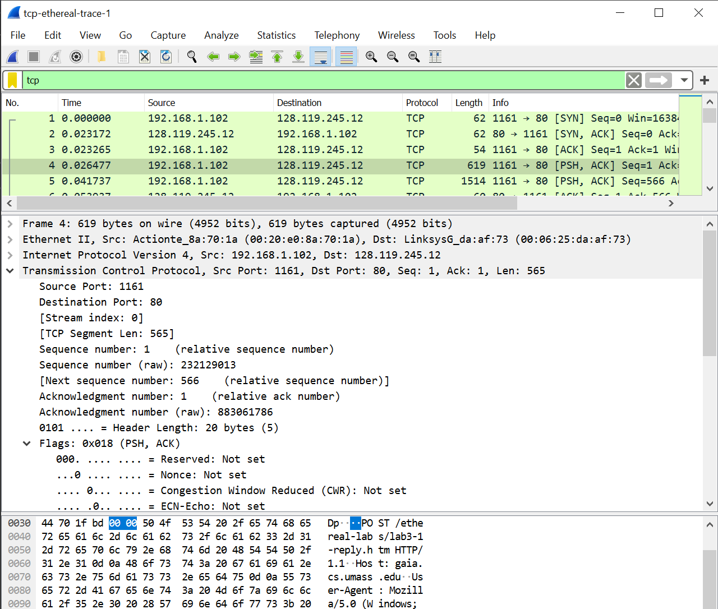
   1. The sequence number of segment 4 which contains the HTTP POST command is 1.
7. 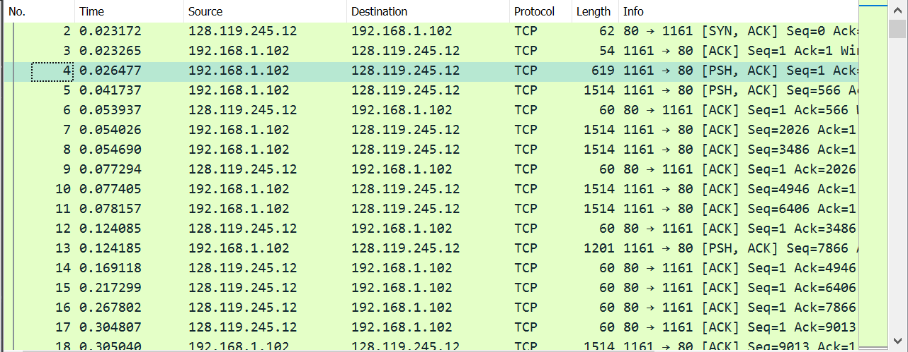
   1. Segment Sequence Numbers:
      1. Segment 1: 1
      2. Segment 2: 566
      3. Segment 3: 2026
      4. Segment 4: 3486
      5. Segment 5: 4946
      6. Segment 6: 6406
   2. Sent Times in seconds
      1. Segment 1: 0.026477
      2. Segment 2: 0.041737
      3. Segment 3: 0.053937
      4. Segment 4: 0.054026
      5. Segment 5: 0.054690
      6. Segment 6: 0.077405
   3. Ack Received Times in seconds
      1. Segment 1: 0.053937
      2. Segment 2: 0.077294
      3. Segment 3: 0.124085
      4. Segment 4: 0.169118
      5. Segment 5: 0.217229
      6. Segment 6: 0.267802
   4. RTT in seconds
      1. Segment 1: 0.02746
      2. Segment 2: 0.035557
      3. Segment 3: 0.070148
      4. Segment 4: 0.115092
      5. Segment 5: 0.162539
      6. Segment 6: 0.190397
   5. Estimated RTT in seconds
      1. Segment 1: 0.02746
      2. Segment 2: 0.875 \* 0.02746 + 0.125 \* 0.035557 = 0.028472125
      3. Segment 3: 0.875 \* 0.028472125 + 0.125 \* 0.070148 = 0.03368160937
      4. Segment 4: 0.875 \* 0.03368160937 + 0.125 \* 0.115092 = 0.04385790819
      5. Segment 5: 0.875 \* 0.04385790819 + 0.125 \* 0.162539 = 0.05869304466
      6. Segment 6: 0.875 \* 0.05869304466 + 0.125 \* 0.190397 = 0.07515603907
8. Length of TCP Segments in bytes
   1. Segment 1: 565
      1. 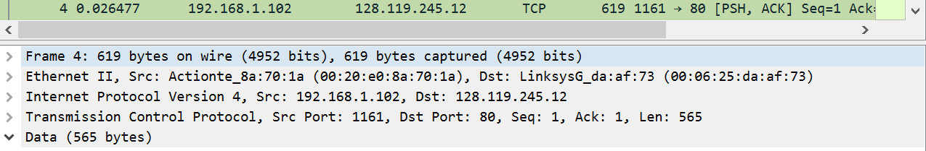
   2. Segment 2: 1460
      1. 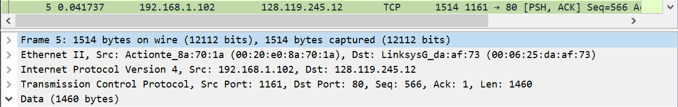
   3. Segment 3: 1460
   4. Segment 4: 1460
   5. Segment 5: 1460
   6. Segment 6: 1460
9. 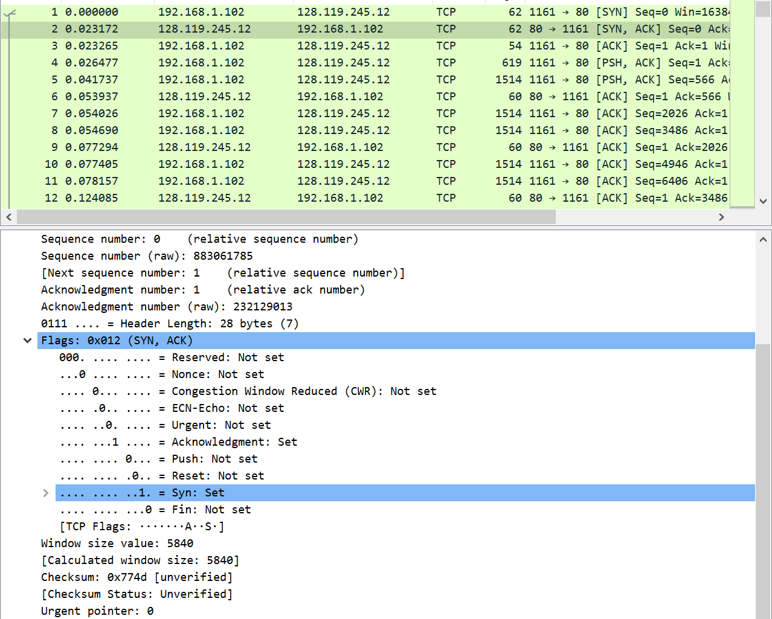
   1. The minimum amount of buffer space is 5840 bytes.
   2. The sender never gets throttled due to lack of receiver buffer space. It grows to 62780 bytes.
10. There are none. I checked for increasing sequence numbers in the Time-Sequence-Graph (Stevens).
11. The receiver typically acknowledges 1460 bytes in an ACK as most segments contain 1460 bytes of data. The only time the receiver seems to ACK every other received segment is before the POST segment is sent. It ACKS both the post segment in frame 4 and the segment in frame 3 together.
12. Average throughput is the total amount of data over the total transmission time.
    1. Total amount of data: last TCP segment sequence number acknowledges minus the first TCP segment sequence number.
       1. 164091 bytes – 1 byte = 164090 bytes
    2. Total transmission time: time of last ACK minus time the first TCP segment is sent
       1. 5.455830 s – 0.026477 s = 5.4294 seconds
    3. Average throughput = 164090 bytes / 5.4294 seconds = 30.2224924 kBps